Online Beauty Parlour Appointment Booking System
Aim
To develop a responsive website that allows customers to search for beauty parlours, explore services and stylist profiles, check available appointment slots, book or cancel reservations, make payments, and provide feedback. The system also helps salon managers and staff manage appointments, schedules, and customer information.
Algorithm
- Start the application.
- Allow customers to register, log in, and manage their personal accounts.
- Display beauty parlours, services, prices, and stylist profiles.
- Allow customers to select a service, stylist, preferred date, and available time slot.
- Check availability and prevent double booking or booking during unavailable hours.
- Allow customers to confirm appointments with full payment or a partial deposit.
- Display upcoming appointments and reservation history.
- Allow customers to reschedule or cancel appointments and submit feedback.
- Allow salon managers and staff to view the reservation calendar, add or edit bookings, manage schedules, and contact customers.
- Display appointment confirmations and reminders.
- Stop the application.

<!DOCTYPE html>
<html>
<head>
<title>Beauty Parlour Booking</title>
<style>
body {
font-family: Arial;
background: #fff0f5;
margin: 0;
}
header {
background: #c2185b;
color: white;
text-align: center;
padding: 20px;
}
.container {
background: white;
max-width: 450px;
margin: 25px auto;
padding: 20px;
border-radius: 10px;
box-shadow: 0 0 10px #ccc;
}
input, select, button, textarea {
width: 100%;
padding: 10px;
margin: 8px 0;
box-sizing: border-box;
}
button {
background: #c2185b;
color: white;
border: none;
cursor: pointer;
}
button:hover { background: #880e4f; }
h2 { color: #c2185b; }
#result { color: green; }
</style>
</head>
<body>

<header>
<h1>Beauty Glow Parlour</h1>
<p>Book Your Beauty Appointment Online</p>
</header>

<div class="container">
<h2>Book an Appointment</h2>

<form id="bookingForm">
<input type="text" id="name"
placeholder="Customer Name" required>

<input type="email" id="email"
placeholder="Email Address" required>

<input type="tel" id="phone"
placeholder="Phone Number" required>

<select id="service" required>
<option value="">Select Service</option>
<option>Haircut - ₹300</option>
<option>Facial - ₹800</option>
<option>Hair Styling - ₹500</option>
<option>Bridal Makeup - ₹3000</option>
<option>Manicure - ₹400</option>
</select>

<select id="stylist" required>
<option value="">Choose Stylist</option>
<option>Ananya</option>
<option>Priya</option>
<option>Divya</option>
</select>

<label>Select Date:</label>
<input type="date" id="date" required>

<label>Select Time:</label>
<select id="time" required>
<option value="">Choose Time</option>
<option>10:00 AM</option>
<option>11:00 AM</option>
<option>12:00 PM</option>
<option>2:00 PM</option>
<option>3:00 PM</option>
<option>4:00 PM</option>
</select>

<button type="submit">Book Appointment</button>
</form>

<p id="result"></p>

<h2>Appointment Details</h2>
<div id="appointments"></div>
</div>

<script>
// Set minimum date to today
document.getElementById("date").min =
new Date().toISOString().split("T")[0];

let bookings = [];

document.getElementById("bookingForm")
.addEventListener("submit", function(event) {
event.preventDefault();

let booking = {
name: document.getElementById("name").value,
email: document.getElementById("email").value,
phone: document.getElementById("phone").value,
service: document.getElementById("service").value,
stylist: document.getElementById("stylist").value,
date: document.getElementById("date").value,
time: document.getElementById("time").value
};

let exists = bookings.some(b =>
b.stylist === booking.stylist &&
b.date === booking.date &&
b.time === booking.time
);

if (exists) {
document.getElementById("result").textContent =
"This stylist's time slot is already booked.";
return;
}

bookings.push(booking);

document.getElementById("result").textContent =
"Appointment booked successfully!";

showAppointments();
this.reset();

document.getElementById("date").min =
new Date().toISOString().split("T")[0];
});

function showAppointments() {
let output = "";

bookings.forEach((b, i) => {
output += `
<div style="border-bottom:1px solid #ccc;padding:10px">
<b>${b.name}</b><br>
Service: ${b.service}<br>
Stylist: ${b.stylist}<br>
Date: ${b.date}<br>
Time: ${b.time}<br>
<button onclick="cancelBooking(${i})">
Cancel Appointment
</button>
</div>`;
});

document.getElementById("appointments").innerHTML = output;
}

function cancelBooking(index) {
bookings.splice(index, 1);
showAppointments();
document.getElementById("result").textContent =
"Appointment cancelled.";
}
</script>

</body>
</html>

Output:
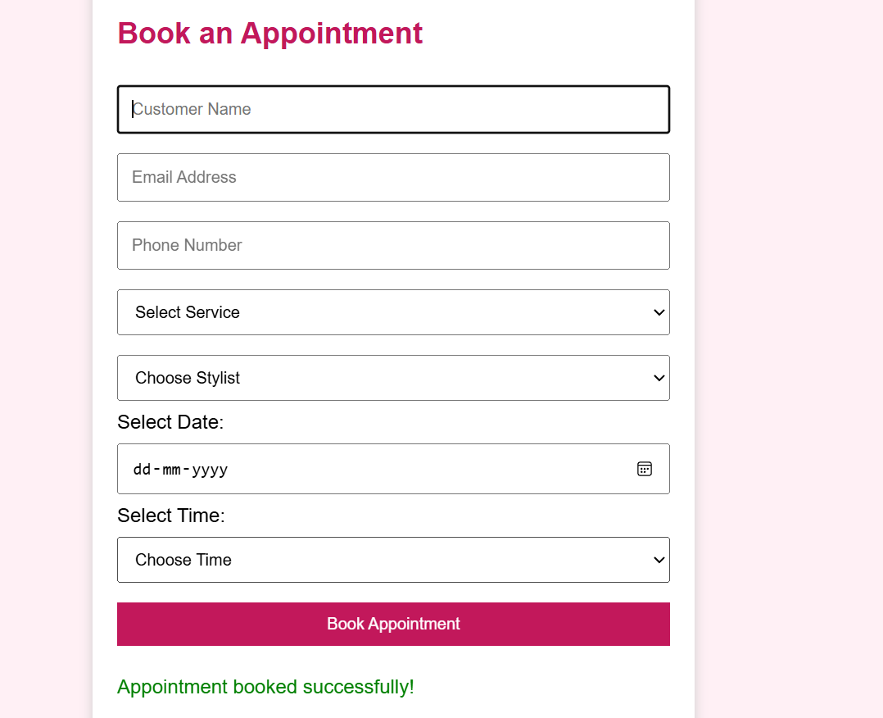
Result
The website allows customers to select a beauty service, stylist, date, and time, book appointments, view their bookings, and cancel appointments.

